**9 Marvelous Health Benefits of Cape Gooseberries (Rasbharies)**

Sushmita Sengupta  |  Updated: March 20, 2017 10:55 IST

[Tweeter](http://twitter.com/share?url=http%3A%2F%2Ffood.ndtv.com%2Ffood-drinks%2F9-marvelous-health-benefits-of-cape-gooseberries-rasbharies-1670679)[facebook](https://www.facebook.com/sharer.php?u=http%3A%2F%2Ffood.ndtv.com%2Ffood-drinks%2F9-marvelous-health-benefits-of-cape-gooseberries-rasbharies-1670679&text=9+Marvelous+Health+Benefits+of+Cape+Gooseberries+%28Rasbharies%29)[Google Plus](https://plus.google.com/share?url=http%3A%2F%2Ffood.ndtv.com%2Ffood-drinks%2F9-marvelous-health-benefits-of-cape-gooseberries-rasbharies-1670679)[Reddit](http://www.reddit.com/submit)

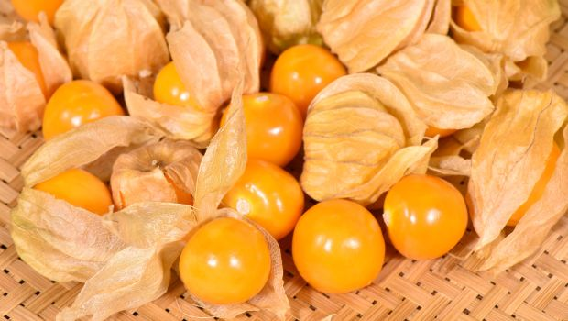Highlights

* Cape gooseberry is more commonly known as rasbhari in India
* They are rich in vitamins, antioxidants and soluble fibre
* They can help boost your immunity & control high blood pressure

Cape gooseberries, more commonly known as*Rasbhari* in India, is a small orange berry fruit. It has various names like golden berries, inca berry and ground berries. They are usually grown in warm regions like South Africa, South America, Central America, India and China. Its tarty taste has many admirers who can’t wait for the arrival of this seasonal fruit. You can have them fresh as a healthy snack and also use them as a topping for desserts or in puddings. Did you know that cape gooseberries apparently contain more antioxidants than broccoli, apples, and pomegranates? If you didn't, here's a list of some wonderful health benefits of eating cape gooseberries.    
  
**1. Store house of Vitamin C and antioxidants**  
  
Cape gooseberries have abundant [Vitamin C](http://food.ndtv.com/health/6-amazing-vitamin-c-benefits-for-skin-and-health-1426801) much more than lemons! Not only is Vitamin C good for your skin, but it also helps in boosting your immunity.   
  
(Also read: [4 foods That Boost Your Immunity](http://food.ndtv.com/food-drinks/4-magical-foods-that-could-help-boost-your-immunity-1436849))



**2. Good for your eyes**  
  
Apart from Vitamin C, cape gooseberries are also rich in [Vitamin A](http://food.ndtv.com/health/5-hidden-signs-and-symptoms-of-vitamin-a-deficiency-often-ignored-1664573) which improves eyesight, and immunity. Cape gooseberries are rich in iron too which further boosts your vision. 



**3. Controls high blood pressure**  
  
Due to the presence of phyto-chemicals such as polyphenols and carotenoids, cape gooseberries can regulate high blood pressure levels. These chemicals along with the soluble pectin fibre keep bad cholesterol levels in check and promote heart health.  
  
(Also read: [Control High Blood Pressure With These 5 Everyday Foods](http://food.ndtv.com/health/control-high-blood-pressure-with-these-5-everyday-foods-1625645))

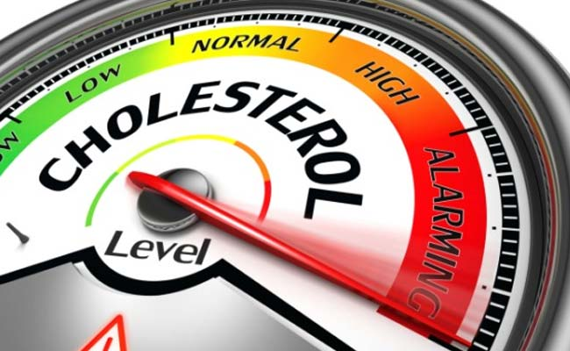

**4. Bone strength**  
  
Being high in calcium and phosphorous, these berries help in making your bones stronger.



**5. Can control diabetes**  
  
Cape gooseberries contain immense soluble fibre like fructose which can prove beneficial for diabetic patients. These berries can help lower the blood sugar levels.



**6. Promotes weight Loss**  
  
Low in fat and calories, a handful of cape gooseberries make for a great snack or a meal filler to support your weight loss goals.  
  
(Also read: [What to Eat and Avoid for Weight Loss](http://food.ndtv.com/food-drinks/low-fat-food-what-to-eat-and-what-to-avoid-for-weight-loss-1630113))



**7. Eases digestion**  
  
Once again, fibre plays an important role in managing your digestive processes. Fibre-rich cape gooseberries are great to add to your diet. Moreover, the pectin fibre it contains helps calm the disturbed gastro-intestinal (GI) tract, prevents constipation and also serves as a great laxative.  
  
(Also read: [5 Fiber-Rich Foods You Must Have Everyday](http://food.ndtv.com/food-drinks/5-fiber-rich-foods-you-should-be-eating-everyday-1201686))



**8. Anti-Inflammatory properties**  
  
Cape gooseberries are rich in anthocyanins which prevents inflammation caused by pain, swelling, and redness. Also, due to the presence of polyphenols and other antioxidants, these berries may help in treating disorders like asthma which is basically the inflammation of tracheal passage.   
  
(Also read: [7 Best Anti-Inflammatory Foods You Must Add to Your Diet](http://food.ndtv.com/health/7-best-anti-inflammatory-foods-you-must-add-to-your-diet-1640371))



**9. Fights cold and flu**  
  
Antioxidant-rich cape gooseberries can protect you against common cold and flu attacks. Consume them with tea or hot water at least twice a day. It will soothe your clogged nasal passage and you will begin to feel much more relaxed.  
  
(Also read: [5 Magical Home Remedies for Cold You Probably Haven't Tried Yet​)](http://food.ndtv.com/health/5-magical-home-remedies-for-cold-you-probably-havent-tried-yet-1457433)



Cape gooseberries may boast of a host of health benefits, however, one must observe caution while consuming these delicious berries. Unripe cape gooseberries can contain alkaloids which may cause allergic reactions.